**COMP30022 Project Inception Checklist**

Team Name: Team Baldwin

Supervisor: Doc Wallace

**Process**

* Do you have a communication tool? If so, which one?

The team uses Slack and WeChat to communicate to the client and with team members and uses zoom meetings for more coordinated partner work or client interviews.

Trello is used as a checklist from the scrum master to assign work and track work completed.

* Where are you storing team documents?

Team documents are stored on the GitHub under ‘docs’ folder.

* Are there minutes of meetings? If so, give a link to where they are stored.

The team mainly communicates on WeChat. One Zoom meeting is held weekly from week 2, and the result of the meeting is recorded in a word document on the GitHub repository. (docs- week6 – meeting mins)

https://github.com/Karliex/Team_045-IT-project

* Have you set up a repository? If so, which one?

A repository has been set up on GitHub and set it private. The tutor has been invited in as a collaborator.

https://github.com/Karliex/Team_045-IT-project

* 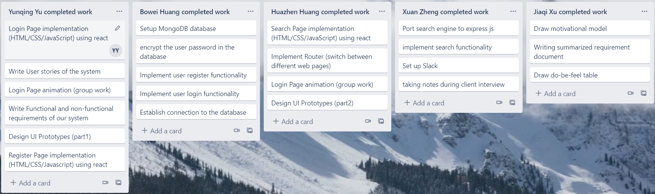Evidence of tasks being assigned.

It is a screen shot of our Trello dashboard. All work that has been done is shown in this pic. And there is also a list of work assigned to specific team members that is under review.

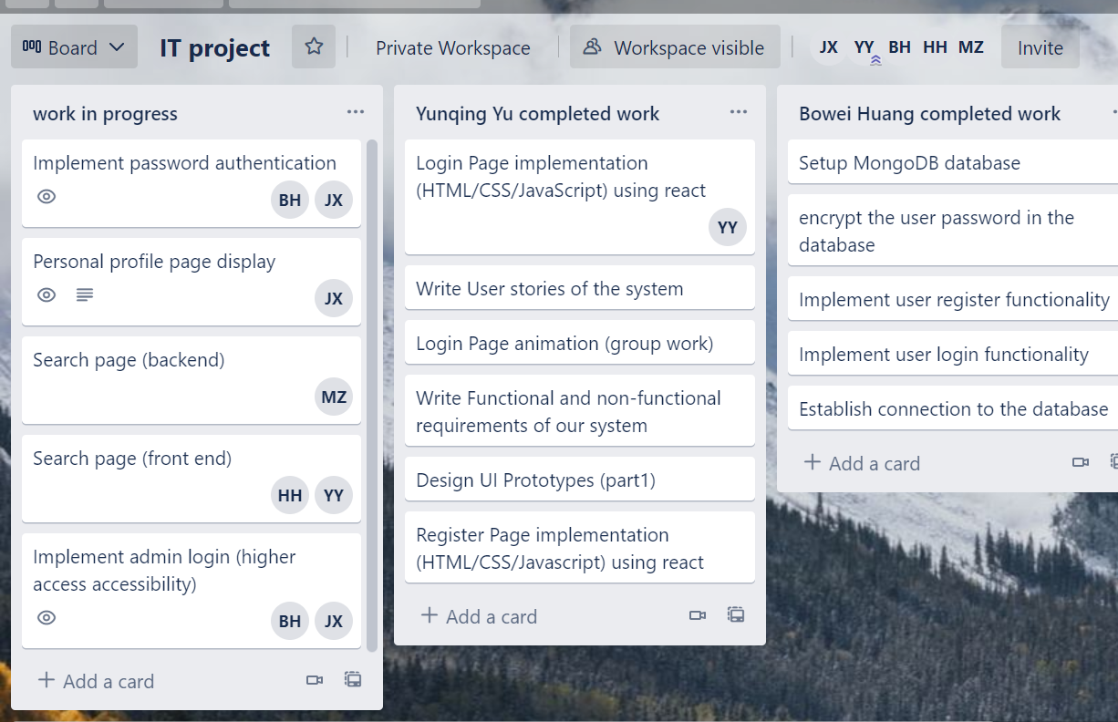

* Are all team members contributing? Elaborate as needed.

All team members are contributing to the teamwork, as seen in the above screenshot. Equal amount of teamwork has been distributed to each team member with regard to their respective skillset and background knowledge.

|  |  |
| --- | --- |
| Role | Team member |
| Technical Lead | Xuan Zheng |
| Product Owner | Jiaqi Xu |
| Scrum Master | Yunqing Yu |
| Quality Lead | Bowei Huang |
| UI & Testing lead | Huazhen Huang |

**Artefacts**

What requirements artefacts have been developed? Give a link to them.

* Interview Strategy
  + Project background
  + Interview questions and notes
* Use Case Diagram
* Motivational Modelling
  + Do-Be-Feel Table
  + Motivation Map
* Product Backlog (list of user stories in different epics, labelled with priority)

What design artefacts have been developed? Give a link to them.

* Flow Diagram
* UI Wireframe

Design artefacts are under ‘docs’ folder and all requirement artefacts are written in ‘Requirement elicitation’ under ‘Requirements’ subfolder

Link:

https://github.com/Karliex/Team_045-IT-project